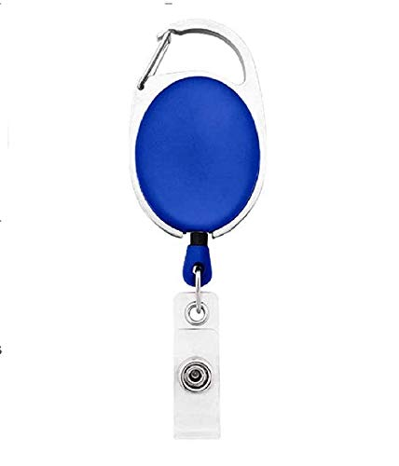

EMPLOYEE CARD

***EMP1177***

|  |  |
| --- | --- |
| **LUCY HOLMES** | PHOTO |
| **Human Resource** |
| **Joining:04/21/2022** |
| **Blood Group:B-VE** |
| **Phone:7382016834** |

www.companywebsite.com